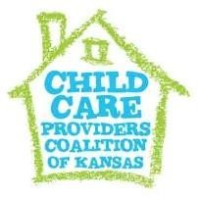
Child Care Providers Coalition of Kansas, Inc.
34th Annual Professional Development Event and Conference
PLAY Academy – Providers Learning and Advocating for Young Children

It’s that time of year again to start thinking about our upcoming professional development event. Due to current circumstances, we have decided to continue with our virtual format. We would like to offer you an opportunity to be one of our amazing virtual vendors. Our virtual event will be held on April 23– 28, 2022.

What is a virtual booth?

We will create a Facebook event where all event participants will be invited to join in on activities. Vendors will create their virtual booth by posting a graphic and link to your business/organization page. Your organization will then share information the comments. You can redirect participants to another page for more information, but we would like vendors to continue to share in our event. We are also asking each company to do a giveaway (gift card or product) in their virtual booth. This will be shipped directly from the vendor to the winner.

If this is something that you would like to participate in, please let me know by
March 13, 2022. You can register online at: https://www.ccpcofks.com/vendor-application

Virtual Non-Profit Vendor Package
• Access to CCPC Facebook Event/Link to your business page
• Company name listed in event program, web page, and on social media
• Gift Card/Product Donation

Hope to hear from you!
Angie Carnes
ccpcconference@gmail.com

